*Research Article*

*Şafak Kırkar*

**Time Series Modelling for SST by Machine Learning**

**Abdallah DWIKAT and Zafer ASLAN**

*Department of Computer Engineering, Faculty of Engineering, Istanbul Aydin University, Istanbul,* *34295, Türkiye*

*\*E-mail address:* [abdallahdwikat@stu.aydin.edu.tr](mailto:abdallahdwikat@stu.aydin.eu.tr), [zaferaslan@aydin.edu.tr](mailto:zaferaslan@aydin.edu.tr),

***ABSTRACT***

*Sea Surface Temperature (SST) measurements benefit a wide spectrum of operational applications, including climate seasonal monitoring, military defense operations, validation of atmospheric models, tourism, and commercial fisheries management. Understanding SST patterns in time series provides fundamental information on the global climate system and contributes to more effective policymaking. Through comprehensive model evaluation and comparison, the paper aims to identify the most reliable techniques for ongoing environmental monitoring and prediction, ultimately contributing to sustainable development and climate resilience. These predictions are crucial for mitigating environmental disasters and understanding the impacts of SST on climate change by reducing CO2 emissions. Various machine learning algorithms like statistical models of Auto-Regressive with its split Auto-Regressive Moving Average (ARMA), and Auto-Regressive Integrated Moving Average (ARIMA) can be applied for future scenarios of SST. Long-short memory (LSTM) allows us to effectively compare performance between supervised and unsupervised machine learning algorithms by performance metrics showing the advantages and disadvantages of each model usage. These algorithms can uncover complex relationships on historical daily average SST data between 2004 and 2023 in Mersin, Southern Turkey at the Mediterranean Sea. Special key solutions were applied during building the models to improve the model’s performance first, and to make the model at its best usage for solving real-world solutions in climate change and other benefits. The models were applied in short-term and long-term forecasts with high-quality results of SST by exploring the best performance of each Auto-Regressive statistical model. LSTM with a window size of 8 performed best results as a short-term dependency forecast with a strong ability to forecast specific trends and seasonality. LSTM with 365 window size able to forecast a year or more of un-seen future which showed increases of minimum SST in winter trends in 2024 with 99 % R square performance.*

***Keywords:*** *Climate changing, LSTM, Prophet, Auto-Regressive, Mediterranean, Forecasting.*

# **INTRODUCTION**

Human-induced actions causing global warming significantly impact the sea temperature and other climate features, consequently leading to substantial changes in Sea Surface Temperature (SST) patterns. The oceans act as a carbon sink, as part of the carbon sink, absorbing and storing carbon dioxide. The oceans also absorb heat from the atmosphere. More than 90% of the excess heat generated as a result of climate change has ended up in the sea, along with roughly 30% of the carbon dioxide produced by humans from burning fossil fuels since the start of the Industrial Revolution [1].

SST is an essential parameter to study marine ecosystems and weather prediction, and it is also important for atmospheric model simulations. Forecasting SST can aid in reducing losses and optimizing resource use. Water covers 71% of Earth's surface. Water is doing a great job of taking up carbon dioxide, however, the huge quantity of carbon dioxide humans has been pumping into the atmosphere is more than the oceans can handle [2]. This saturation of the ocean with carbon dioxide is causing the chemistry of the water to change. Accurate predictions of SST are needed for ultimately contributing to sustainable development and climate resilience. This includes plans and solutions, to operate water resource projects in real-time, manage resources well, and take steps to lessen the impact of climate events on the environment [3].

The primary goal of the study is to forecast SST values in Mersin province by employing machine learning techniques and criticizing the results behind each model for specific real-world usages. Turkey's main gateway to the Mediterranean Sea is Mersin city which has the second largest port in Turkey, and the largest one that is located on the Mediterranean Sea serving as a major hub for container and general cargo with extensive infrastructure to support maritime traffic [4]. For future work usage, we chose Mersin City specifically to uncover the relationship between the SST and maritime traffic which Mersin City can have great impact for this study matter with Port Cargo share handled reaching total of 40 million tons in the last 3 years [5].

The Mediterranean area has been defined as a hot spot for climate change. It is crucial to study the behavior of the Mediterranean Sea in the past and to monitor its current situation to understand possible future scenarios in the region. [6].

Additionally, SST in the region of Mersin south-eastern part of Turkey is one of the highest levels of daily SST in the Mediterranean Sea as shown below in Figure 1. Data, study area, and methodology have been presented in the following part of the paper.

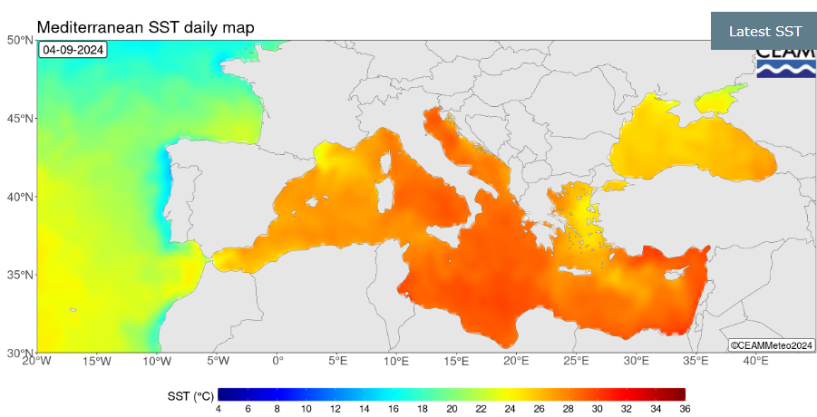

**Figure 1.** Mediterranean SST daily map. [6]

# **DATA AND METHODOLOGY**

17 years of daily average SST data were used for training the models (2004-2020), and 3 years for testing (2021-2023). After data collection, converting the Unit from Kelvin to Celsius was used by subtracting -273.15 from the collected data using Python to have a Celsius unit as a result. Data was collected between the 1st of January 2004 to 31st of December 2023, total of 7305 rows × 1 column. Tuning both the Statistical models of AR and LSTM model steps was applied by providing a full Time Series study on the SST historical data with necessary plots and results to be used before building the models.

## **2.1. Study Area:** Daily average of historical Sea Surface Temperature (SST) data gathered for Mersin province is collected from satellite data from NASA Earth data (0.25x0.25) collection in-situ with the coordinates format (minimum longitude, minimum latitude, maximum longitude, maximum latitude) at (34.5165, 36.6871, 34.7665, 36.8371) area is shown in Figure 2.

## (<https://data.marine.copernicus.eu/product/SST_MED_PnHY_L3S_MY_010_042/description>) to get the most reliable historical daily data on average Sea Surface Temperatures.

N

**Figure 2.** Area of Study

## **2.2. Methodology:** The models we chose can be grouped into three main categories based on three goals. The first is the statistical models (AUTO-Regressive) AR and Auto-Regressive Integrated Moving Average (ARMA), The second is the Prophet additive time series model, and the third is Artificial Neural Network (ANN) Specifically Long Short-Term Memory (LSTM). The LSTM model is a subpart of RNNs in Deep Learning known for its robustness and ability to analyze time series patterns. The indicators used for evaluating the performance of models are MAE, MSE, and R^2 score. For additional step-by-step building the models, GitHub directory includes the four models used can be found at the end of the paper.

Statistical models rely on traditional statistics to study past data and come up with ways to forecast SST which makes it hard to predict the long-future forecasts using the statistical models due to computational cost. We deployed a key solution for this problem by using Walk Forward Validation in the AR models. Walk Forward Validation works by continuous data collection which makes the model rely on real data instead of forecasted ones to lessen the error metric over time due to any change in the water or other impacts such as global warming. This made the forecasts and the study with AR models a current topic and a real-world useful solution by providing useful forecasts for the unseen future with continuous data collection.

**2.2.1. Auto-Regressive (AR):** Auto-Regressive (AR) statistical models are used for predicting short-future predictions which can be useful for accurate predictions such as military operations and disaster management. Additional AR models are used such as ARMA that improve the model to be able to predict more precisely unusual events/activities in the sea by adding the Q value or what’s called error lag. However, after applying a value for Q in our ARMA model, the model suffered from skipping the forecasts on the test set starting from 95 steps and forward. For this case, we could successfully use the Auto-Regressive (AR) model with a lag of 8.

In statistics, an autoregressive (AR) model is a representation of a type of random process. It can be used to describe certain time-varying processes in nature, economics, behavior, etc. The autoregressive model output variable depends on its previous values linearly on its previous values and a stochastic term (an imperfectly predictable term); thus, the model is in the form of a stochastic difference equation (or recurrence relation) which should not be confused with a differential equation. Together with the moving-average (MA) model, it is a key component of the more general autoregressive–moving-average (ARMA) and autoregressive integrated moving average (ARIMA) models of time series. They have a more complicated stochastic structure. Contrary to the moving-average (MA) model, the autoregressive model is not always stationary as it may contain a unit root.

Large language models are called autoregressive, but they are not a classical autoregressive model in this sense because they are not linear. The AR model is given by the Equation 1[11]:

**Xt​:** The current value of the time series at time t.

**c:** The intercept term or constant.

**i:** Index of the lag (past time step) ranging from 1 to p.

**p:** The order of the AR model, indicating how many past time steps are used.

**ϕi​:** The autoregressive coefficients for each lag i.

**Xt−i​:** The past values of the time series at lag i.

**ϵt​:** The error term or white noise at time t.

There is a direct correspondence between these parameters and the covariance function of the process, and this correspondence can be inverted to determine the parameters from the autocorrelation function.

**Xt=∑i=1pφiXt−i+εt.**However, ARIMA models are also capable of modelling a wide range of seasonal data.

**2.2.2. Prophet:** The Prophet additive model was used to predict SST Values for long-future predictions, by adding time features (day of the year, season, month, year. etc.). Using the time features in the Prophet model helps the model understand the dataset and the pattern of SST in seasonal patterns and at different times of the year.

Prophet is a procedure for forecasting time series data based on an additive model where non-linear trends are fit with yearly, weekly, and daily seasonality, plus holiday effects. It works best with time series that have strong seasonal effects and several seasons of historical data. Prophet is robust to missing data and shifts in the trend and typically handles outliers well. Prophet fit models in Stan so that you get forecasts in just a few seconds with fully automatic usage and allow users to tune specific forecasts for improvement. Stan is a state-of-the-art platform for statistical modeling and high-performance statistical computation. Many users rely on Stan for statistical modeling, data analysis, and prediction in the social, biological, and physical sciences, engineering, and business.(The official Stan documentation website: <https://mc-stan.org/docs/> )

The Prophet model was introduced by Facebook (S. J. Taylor & Letham, 2018), originally for predicting daily data with yearly and weekly seasonality, plus holiday effects.

Prophet can be considered a nonlinear regression model of the form below [12].

Prophet additive model can be represented as:

* (y(t)) is the observed value at time (t)
* (g(t)) describes a piecewise-linear trend (or “growth term”).
* (S(t)) describes the various seasonal patterns.
* (h(t)) captures the holiday effects
* (εt) is a white noise error term.

**2.2.3. RNNs,** **Long-Short Term Memory (LSTM):** LSTM model was used and fitted to predict SST by providing a short window size of 8 in one model, and a long window size of 365 in the other. The comparison between the short window size and the long one in the results can show the different advantages and disadvantages for each. The use of neural network technology has brought about many good results in studying water and simulating water resources [7] because they can represent both simple and complex systems without needing the assumptions typical of most traditional statistical methods [8]. LSTM has the ability to recall past inputs and make decisions using information from both past and present inputs. The adoption of more intricate RNN designs and other deep learning methods like long short-term memory has demonstrated superior performance compared to traditional RNNs in certain cases [9, 10].

RNNs are a special class of neural networks that operate on The LSTM model (Hochreiter and Schmidhuber 1997a) is a powerful recurrent neural system specially designed to overcome the exploding/vanishing gradient problems that typically arise when learning long-term dependencies, even when the minimal time lags are very long (Hochreiter and Schmidhuber 1997b). In short, the LSTM architecture consists of a set of recurrently connected sub-networks, known as memory blocks. The idea behind the memory block is to maintain its state over time and regulate the information flow through non-linear gating units. Figure 3 below displays the architecture of a vanilla LSTM block, which involves the gates, the input signal x(t), the output y(t), the activation functions, and peephole connections (Gers and Schmidhuber 2000). The output of the block is recurrently connected back to the block input and all the gates [13].

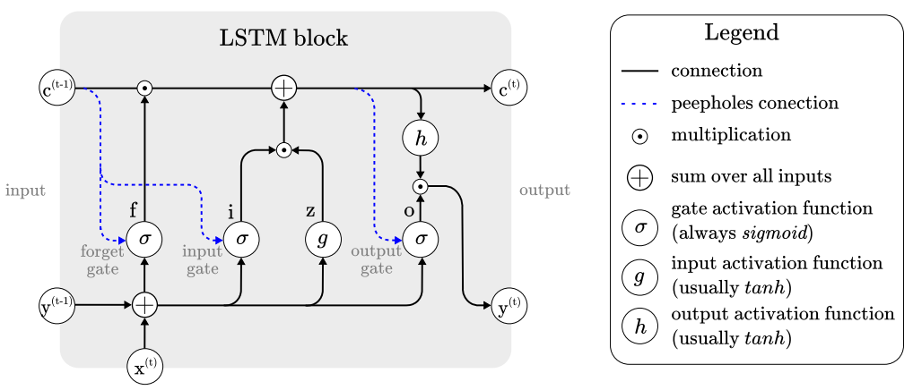

**Figure 3.** Architecture of typical vanilla LSTM block [13]

## **2.2.4. Performance Metrics**

Absolute-difference metrics:metrics all focus on measuring the average dispersion error, without attention to bias. The smaller the average error, the better the method. We turn first to absolute-difference metrics. They are good model selection criteria when (repeated) average performance is important [14].

* **Mean Absolute Error (MAE):** MAE measures the average of the sum of absolute differences between observation values and predicted values and corresponds to the expected loss for the L1 loss function. Equation 3 shows *Mean-Absolute Error.*

Where,  is the forecasted value and is the real one [14].

* **Mean Squared Error (MSE**): Mean Squared Error (MSE) is another common metric used to evaluate the accuracy of a model. Unlike MAE, which averages the absolute differences, MSE averages the squared differences between the observed and predicted values. This means that MSE gives more weight to larger errors, making it more sensitive to outliers.Equation 4 explains Mean-Squared Error [14].

(4)

* **Goodness of fit or Coefficient of Determination:** R2 measures the improvement of the regression line over a simple mean line, (Eq. 5a and b).

(5b)

is the sum of the squared error of the regression line and is the sum of the squared error of the mean line. The value of R2 lies between 0 and 1, a higher value of R2 indicates the model is better [14].

# **ANALYSES**

Only SST as a feature and as a target was used. The Date is an index used in the machine learning models, however, other features can be used to reveal statistical descriptions and correlational values with SST for future work. Feature Engineering techniques make modeling the target easier to predict with more efficient results. Time Series plots and study during the work was done to find the best parameters in our case study. The use of those plots aligned with tuning the AR models and the LSTM models as well. In Python, we used the scatter plot library which offers the forecasts as points for a better understanding of the forecasting trends at specific days and unusual trends as well.

## **3.1. Auto Regressive Model (AR)**

To find the best parameters for the ARMA (Auto Regressive Moving Average) model, we automated the tuning hyperparameter by setting a range of (p) values “p_params = range(0, 25, 8)” and (q) values “q_params = range(0, 3, 1)” in the ARMA model and finding the possible values in a grid that can help us pick the appropriate parameters based on less mean absolute error value and less computational complexity, to merge the results as a grid using Python.

**Table 1.** Mean Absolute Error Parameter Grid

|  |  |  |  |  |
| --- | --- | --- | --- | --- |
| **Q / P** | **0** | **8** | **16** | **24** |
| **0** | 4.053 | **0.1593** | 0.1569 | 0.1545 |
| **1** | 2.0843 | 0.1624 | 0.1529 | 0.1545 |
| **2** | 1.1812 | 0.1539 | 0.1515 | 0.1509 |

As shown in Table 1 above, the lowest MAE value is at (p) value of 24 days and (q) value of 2 which represents the most computationally complex model. The model of (8, 2) provides 0.1539 MAE and is less complex than the first one so it was chosen to be used for this purpose. The AR model uses a p-value only which looks like (p, 0, 0). ARMA uses p and q but not d (p, 0, q), and ARIMA (Auto Regressive Integrated Moving Average) uses the three of them (p, d, q). After building the ARMA model with (8, 0, 2), the model couldn’t successfully forecast on the test set, and it skipped significant parts starting from 95 steps forward. For this reason, we applied a simpler model which is AR with the parameter shown in Table 3 above (8, 0, 0) having 0.1593 mean absolute error value.

## **3.2. Prophet Model**

Prophet model features used were the day of week, quarter, month, year, day of the year, day of the month, week of the year, weekday, season, and SST as the target. As a time-series model, those features helped the model understand the trend pattern of SST values at specific times of the data we trained the model on. Boxplot showing the SST by season for each year between 2004 and 2023 helps clarify the outliers and the trends in each quarter of the specific year in Figure 4.

**Figure. 4** Boxplots of SST by season (2004-2023) in Mersin

SST values in Figure 4. above shows an increasing trend in fall and winter in recent years.

## **3.3. Long-Short Term Memory Model**

The LSTM model needs hyperparameter steps as well to be able to forecast the SST seasonal trends. After our findings from the time series plots, there is a strong correlation between the SST and itself in previous days. We built an additional model for the LSTM model which is the SST value 1 year earlier. This was done by assigning the window size in the LSTM as 365. The other LSTM model window size was used as 8, which allows us to see the results of the AR model with a lag value of 8 and the LSTM model with a window size of 8 and compare the results. This way we can have two models built for short-term forecasts and two models for long-term SST forecasts using and picking the most powerful ones after testing the four models. Forecasting long-term dependency for more than a year will let the model use its predictions as an input for the next step which will make the results less efficient over time. This is the case for any machine learning model; however, we focused on building the most robust model possible so we can forecast a year or two effectively to be used in policy-making and climate change, and also predict short-term forecasts with the AR and LSTM in disaster management cases and military operations with high-quality forecasts.

Continuous collection of the data together with our key solution using Walk Forward Validation can provide significant impact for improving the forecasts by the latest real data available. Figure 5 belowshows the seasonal decompose trend that our full dataset follows proving the seasonality of the data and the increase of SST over the years reaching high SST values in recent years that were never reached before.

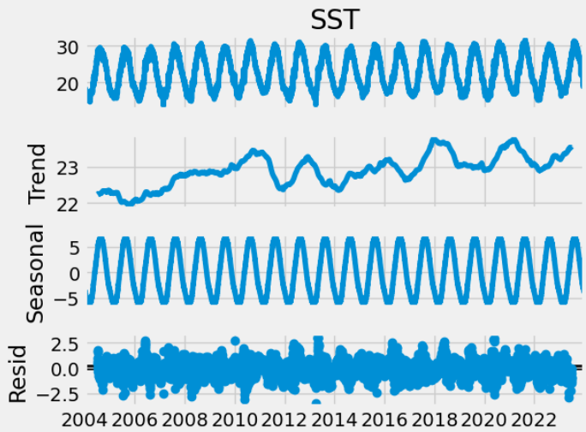

**Figure. 5** Seasonal Decompose trend SST in Mersin

The increase trend in Figure 5 above is noticeable by two main factors, the first is the increases in maximum SST values we reach (in summer), and the second is the minimum SST values we have in recent years which clears the increase of the minimum value (in winter) after the year of 2014. Since 2014 we never reached a similar or colder trend but much higher even between 2014 and the end of 2023.

Climate change is causing the surface waters of the sea to warm. The warming of surface waters is causing changes in water density and the mixing of warmer, surface water with cooler, deeper water [1]. This explains the rise of SST values after 2014 more and more over the years.

Additionally, Figure 6 below shows the SST values that reached above 28 Celsius in Mersin from 2004 to 2023 identifying increases in the sea surface temperature over the years for high values (above 28). Linkage of other factors that happened on this historical data can aid in understanding the SST relation with those actions on heat water.

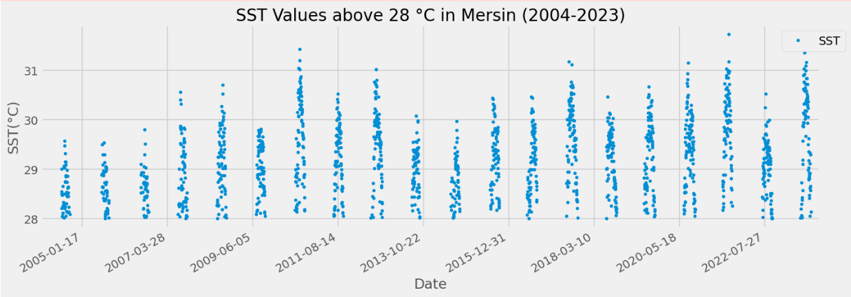

**Figure. 6** SST values above 28 Celsius in Mersin (2004-2023)

The finding from figure 6 above how SST is increasing for the max values above 28 Celsius. Standard deviation represents 4.66 and the mean is 22.9, by merging them which is 22.9 + 4.66 approximately equals 28 degrees Celsius.

# **RESULTS AND DISCUSSIONS**

After exploring four machine learning time series models towards achieving accurate results and robust models to forecast SST values in the future for the SST benefiting the points we criticized, the models we used performed well after training the models on the dataset from 1st January 2004 till 31st December 2020 and split the test set, which is between the 1st of January 2021, and 31st of December 2023, a total of 1095 days. All models could generalize well on the test set however there are some higher performances in some specific models as shown below in Table 2.

**Table 2.** Evaluation Metrics Results on Test Set

| Model name | Metrics | | |
| --- | --- | --- | --- |
| MAPE | MSE | R2 |
| Prophet | 2.86% | 0.79 | 97.08% |
| LSTM  window=8 | 1.60% | 0.26 | **98.79%** |
| LSTM window=365 | 1.83% | 0.30 | 98.57% |
| AR | 1.52% | 0.24 | **98.9%** |

*Evaluation Table*

As a result, the Auto-Regressive model and LSTM model of 8 window size both made the highest metric values shown in Figures 7 and 8.

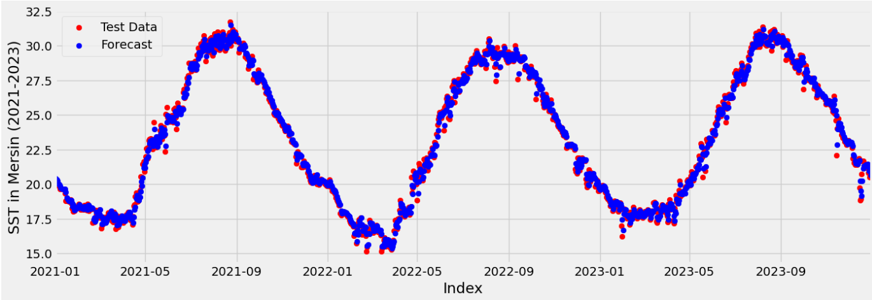

**Figure. 7** AR model performance on test set

Note: Walk Forward Validation was applied on the test set for the AR model.

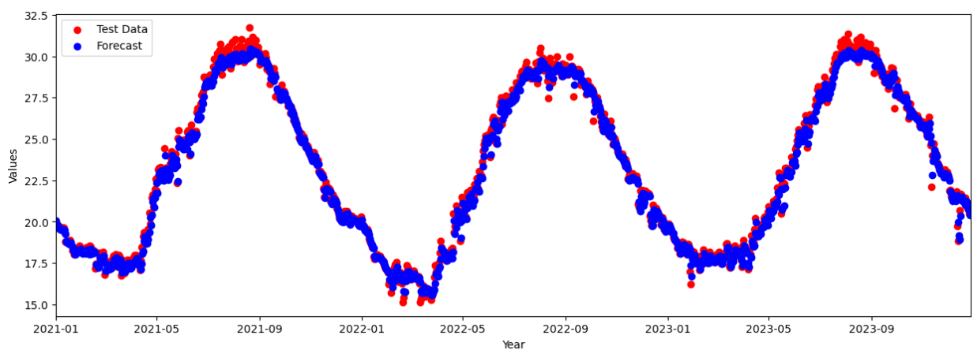

**Figure. 8** LSTM (window=8) model performance on test set

Using AR was too computationally complex and took a long time to run the model compared with the LSTM. LSTM with a window size of 365 was used to show the difference between the LSTM short window size and long one, and also to uncover the difference to forecast a further un-seen year so we compare it with the Prophet forecasts. In Python, we used the scatter plot library which offers the forecasts as points for a better understanding of the forecasting trends at specific days and unusual trends as well. SST values in Mersin for the year 2024 are shown in Figure 9 below by studying our test set till 31 December 2023 using the LSTM model. As a result between Fig 8 and Fig 9, both LSTM models performed perfectly with 98.79% in Figure 10 and 98.57% in Figure 9 which both successfully could generalize on unseen data, however, it is noticeable in the scatter plots that the window size of 8 in Figure 8 the model could align better, especially in specific point forecasts such as un-usual patterns neither or lessen which seems to have a relationship with near-by window size un-like the Figure 9 which is a bit far-away from specific points forecasts.

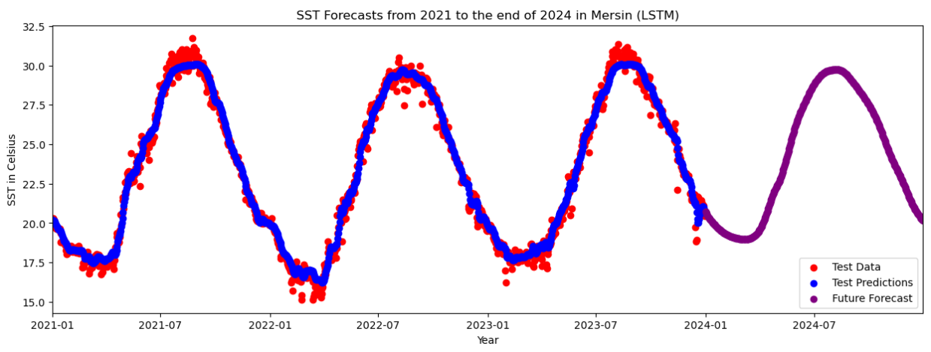

**Figure. 9** LSTM (window=365) model performance on test set

Additionally, it is noticeable from the future forecasts in Figure 11 above the increase of the minimum value in the winter of 2024 which looks higher values than the 2023 winter and 2022 winter as well.

Metricresults from the Prophet additive model for its flexibility and less complexity in long-future predictions made it a suitable option to be used for seasonal trend forecasts. This emphasizes that Prophet is able to forecast predictions for future values of SST that can be used in benefits with economic, and tourism sectors. However, over time we noticed the robustness of the predictions being less in the Prophet model, as there is **an increasing trend of the SST** values more and more over the years, which is shown in Figure 10 (light blue color) in which the real values in red color seems to increase, which makes prophet model predictions less reliable over time. The less reliability towards increase ensures the effect of global warming and other features that identify SST value in increases over years. in addition to the unusual activities/events that might affect the SST for a short or long time, models such as Prophet are less reliable in these situations and not as effective as LSTM for long-term forecasts.

**Figure. 10** Prophet model performance (2021-2024)

# **CONCLUSIONS**

Climate change is causing SST to increasing in general. Water’s functionality in global change aligns by decreasing the CO2 caused by humans on Earth. The “noise” that humans’ impact on the sea makes the SST increase. Using the latest machine learning techniques, we could successfully identify the SST trend over historical data and test the models for unseen future forecasts.

Robustly forecasting SST values helps in policymaking toward climate change and awareness for future forecasts. Both the AR model and the LSTM of 8 window size performed impressive forecasts with short-term dependencies, however, the AR model is a complex task from the computational side and also it had an advantage by using continuous real-data with the use of Walk-Forward-Validation which makes LSTM preferable for this matter. Additional work can be done by applying a hybrid model combining wavelet, LSTM, with AR statistical models to benefit from both solutions. The rising sea temperatures pose threats to ecosystems and marine life. As the sea warms, the window is likely to shift for many species, causing them to move to new locations.

Lastly, SST values are widely important for logistic marine transportations and disaster management. Accurate SST predictions are crucial for disaster prevention and management such as Storm Surges. The Auto-Regressive (AR) statistical model and the LSTM model both effectively improve SST forecasting in high-quality results to avoid or better manage disaster and early detection including hazards or storms warning.

In the end, the findings of this research contribute to enhancing sustainability in the water environment under climate change conditions. The findings offer valuable insights for policymakers, and environmental professionals engaged in future climate-change planning, especially with global warming effects on the environment. The Mediterranean area is a critical region for studying the role of climate change. Continuous research and development are necessary to achieve optimal improvements in forecasting SST by studying additional atmospheric variables and other specific actions that increase or decrease the SST. Time series analyses of daily SST are necessary for building future scenarios in the Mediterranean region. Future studies would be related with hybrid models by considering wavelet details to increase the precision of model outputs.

# **REFERENCES**

[1] NIWA Taihoro Nukurangi, “Climate, Freshwater & Marine Science,” [Online]. Available: https://niwa.co.nz/climate-change-information-climate-solvers/climate-change-and-oceans. [Accessed: Aug. 05, 2024].

[2] National Oceanic and Atmospheric Administration, “Why do scientists measure sea surface temperature?” [Online]. Available: https://noaa.gov. [Accessed: Aug. 04, 2024].

[3] Sangwan and R. Bhardwaj, “Assessing River Flow Patterns in the Context of Climate Change: A Machine Learning Framework,” USBAS, GGSIPU, Delhi, India, [2024].

[4] Port Of Mersin, Wikipedia, [Online]. Available: https://en.m.wikipedia.org/wiki/Port_of_Mersin. [Accessed: Aug. 07, 2024].

[5] İ. Balık, “Antalya Limanı’nın Türkiye’de Elleçlenen Yük İçerisindeki Payı ve Yakın Çevresindeki Limanlar İle Karşılaştırmalı Yük Analizi! Load Analyses of Antalya Port and Near Vicinity of it,” Akademisi Dergisi, vol. 16, no. 3, pp. 1437-1456, 2023. [Online]. Available: https://doi.org/10.35674/kent.1272994. [Accessed: Aug. 11, 2024].

[6] CEAM, “Mediterranean SST Report,” [Online]. Available: https://www.ceam.es/news/mediterranean-sst-report-2/. [Accessed: Aug. 12, 2024].

[7] E. I. McBride, K. Sanchez Medina, and K. Sundmacher, “Hybrid semi‐parametric modeling in separation processes: a review,” Chemie Ingenieur Technik, vol. 92, no. 7, pp. 842-855, [2020].

[8] K. C. Onyelowe, D. R. Eidgahee, H. Jahangir, F. I. Aneke, and L. I. Nwobia, “Forecasting shear parameters, and sensitivity and error analyses of treated subgrade soil,” Transportation Infrastructure Geotechnology, vol. 10, no. 3, pp. 448-473, [2023].

[9] D. Zeebaree, Q. Abdulazeez, A. M. Abdullrhman, L. M. Hasan, and O. S. Kareem, “The prediction process based on deep recurrent neural networks: A Review,” Asian Journal of Research in Computer Science, vol. 11, no. 2, pp. 29-45, [2021].

[10] H. C. Kilinc, “Daily streamflow forecasting based on the hybrid particle swarm optimization and long short-term memory model in the Orontes Basin,” Water, vol. 14, no. 3, p. 490, [2022].

[11] R. J. Hyndman and G. Athanasopoulos, Forecasting: Principles and Practice, 2nd ed., Melbourne, Australia: OTexts, 2018, ch. 8. [Online]. Available: https://otexts.com/fpp2. [Accessed: Aug. 12, 2024].

[12] S. J. Taylor, B. Letham (2017). Forecasting at scale. PeerJ Preprints 5:e3190v2 [Online]. Available: https://doi.org/10.7287/peerj.preprints.3190v2, [Accessed: Aug. 12, 2024].

[13] V. Houdt, G. Mosquera, and G. Nápoles, “A review on the long short-term memory model,” Artif. Intell. Rev., vol. 53, pp. 5929–5955, 2020. [Online]. Available: https://doi.org/10.1007/s10462-020-09838-1. [Accessed: Aug. 12, 2024].

[14] M. M. Steurer, R. J. Hill, and N. Pfeifer, “Metrics for evaluating the performance of machine learning based automated valuation models,” Journal of Property Research, vol. 38, no. 2, pp. 99-129, 2021. [Online]. Available: https://doi.org/10.1080/09599916.2020.1858937. [Accessed: Aug. 12, 2024].

[15] B. Stevens, S. Adami, T. Ali, H. Anzt, Z. Aslan, S. Attinger et al., (2024). EarthVirtualization Engines (EVE). *Earth System Science Data*, 16, 2113–2122. Available: [**https://doi.org/10.5194/essd-16-2113 2024**](https://doi.org/10.5194/essd-16-2113%202024) [Accessed: Aug. 12, 2024].

[16] O. Kolay, B. EFE, E. T. Özdemir, Z. ASLAN, (2024). Investigation of the Thunderstorm Statistics and Stability Indices at Istanbul Airport, Türkiye. In Proceedings of the 1st International Hybrid Conference on the Role of Climate Change on Water Resources Management for a Sustainable Future (ICCW 2024), February 29 – March 1, 2024, Istanbul, Türkiye.

[17] O. Kolay, B. Efe, E. T. Özdemir, Z. Aslan, (2024). Investigation of the Thunderstorm Statistics and Stability Indices at Istanbul Airport, Türkiye. *Climate*. (Under Review).

[18] Z. Aslan, B. Efe, (2024). Scientific Interpretation of Sayyib and Vabil. In Proceedings of the International Symposium on The Earth in the Light of Qur’anic Verses and Scientific Data, October 9 – 11, 2024, Ankara, Turkiye.

[19] U. Şener, B. İ. Kılıç, A. Tokgözlü, Z. Aslan, (2023, June). Prediction of Wind Speed by Using Machine Learning. In *International Conference on Computational Science and Its Applications*, pp. 73-86. Cham: Springer Nature Switzerland.

[20] B. İşler, U. Şener, A. Tokgözlü, Z. Aslan, (2024). Prediction of Solar Energy Potential with Machine Learning and Deep Learning Models. *Mathematical Modeling, Applied Analysis, and Computational Methods*. Springer. (In press).

[21]O. SAWALHA, A. DWIKAT, S. MOLA, Z. ASLAN, N. AHMED, M. YETER (2024). Comparing Model Results for Predicting Temporal Variations of SST and Rainfall Rate, In 11th International Symposium on Atmospheric Sciences – ATMOS’24**.**

[22] Enes Birinci, Emrah Tuncay Özdemir, Ali Deniz, Zafer Aslan(2024, August). Analysis of Heavy Rainfall over Cyprus: 23 February 2011 Events.

GitHub Repository: <https://github.com/apodwikat/-Time-Series-Modelling-for-SST-by-Machine-Learning->

LinkedIn: <https://www.linkedin.com/in/abdallah-dwikat-04095927b/>